To submit an Intent to Propose Via CAYUSE:

1: Login to cayuse at: https://sdsmt.app.cayuse.com/ using your Mines single sign on.

If this is your first proposal submission in the Cayuse system, you can contact Jan Matson to arrange one-on-one training.

2: Select “Sponsored Projects” from the Products pick list on the upper right side of the screen

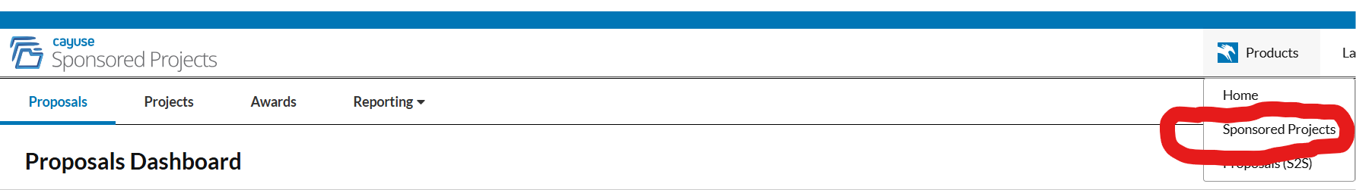

3: Click “+ Start New Proposal” on the upper right side of the screen

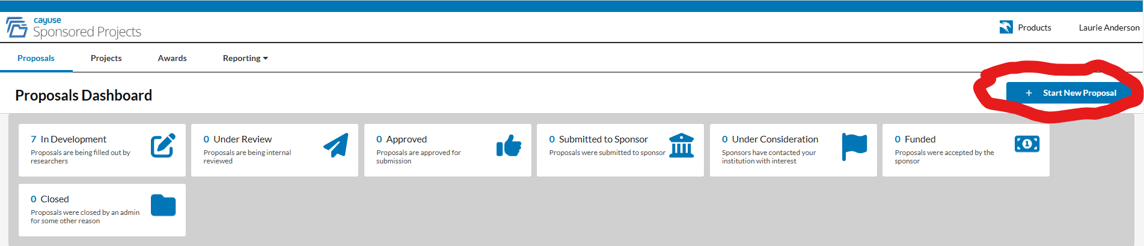

4: Click on the first selection – “Create New Project”.

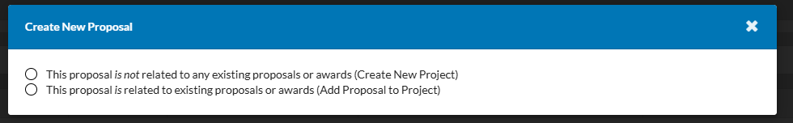

5: Enter title for project and select “Create New Project”
***Your title can be changed prior to submission.
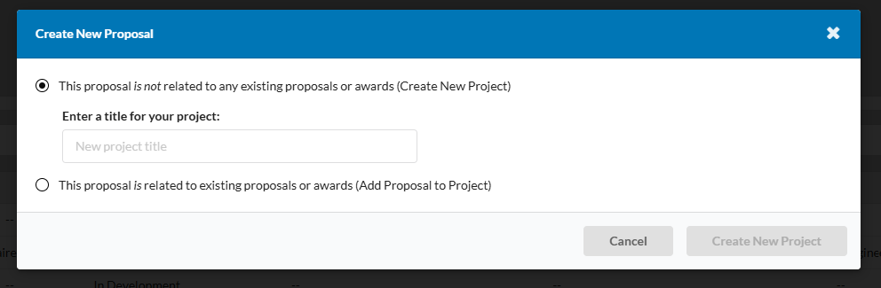

6: In the “General Information” Tab, complete the required (*) fields plus the “Sponsor Deadline Time” plus provide access to the RFP.

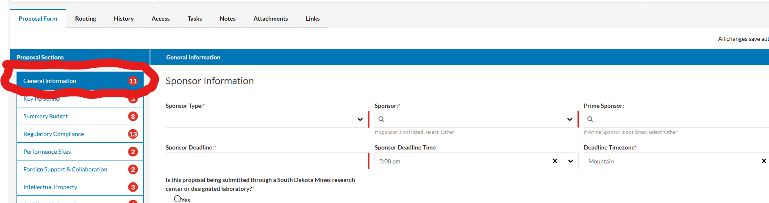

Note the following:
-Sponsor vs. Prime Sponsor: If Mines is submitting a subaward budget to another institution/company/etc. who will be submitting the full proposal, then the “Sponsor” is the organization submitting the proposal and the “Prime Sponsor” is the agency. For example, if SDSU is submitting a proposal to NSF and we have a subaward as part of that proposal, then “Sponsor” = SDSU and “Prime Sponsor” = NSF. If Mines is the submitting organization, then complete information on the funding agency under “Sponsor,” and leave “Prime Sponsor” blank.

-Project Type Definitions: There are many options under this tab. Select the best fit for your project. OSP can change the designation if needed. If in doubt, select “Basic Research.”

- Lead Department for this Submission: Select your academic department. If your unit has more than one entry listed in the pull down, select the name that is followed by a 6-digit numerical code (this is the organization or org code that the university uses to identify your unit).

7: Click on the “Tasks” tab to the left of the “Proposal Form” tab.

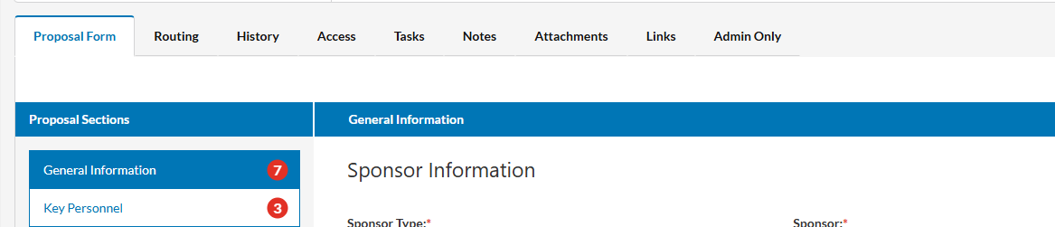

At the far right of the Tasks tab, click on New Task.

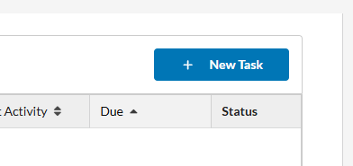

8: On the New Task page, complete (*) fields with the following information:
-Task: New Proposal
-Assign to: Jan Matson
-Description: New Proposal
-Due Date: Use submission deadline.
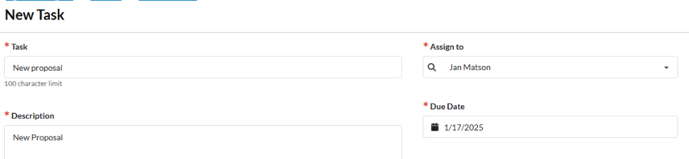

After completing the (*) fields, click on Assign & Send.

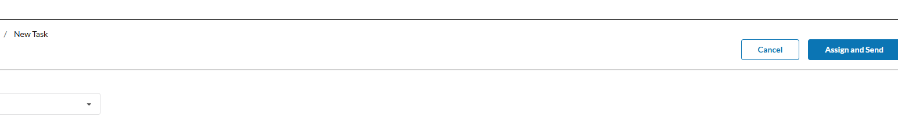

You have now submitted your Intent to Propose!

Once assigned to Jan Matson, she will be in touch via email and will provide the “Draft PI Budget” file for your use. If you have budget information ready, feel free to contact Jan with that information right away.

At this point, you may continue to complete the online proposal form, as you feel comfortable, or work to complete it with Jan.
Completing the remainder of the proposal form:

Key Personnel Tab
Enter PI name and select Principal Investigator in the Role pick list (1 per proposal).
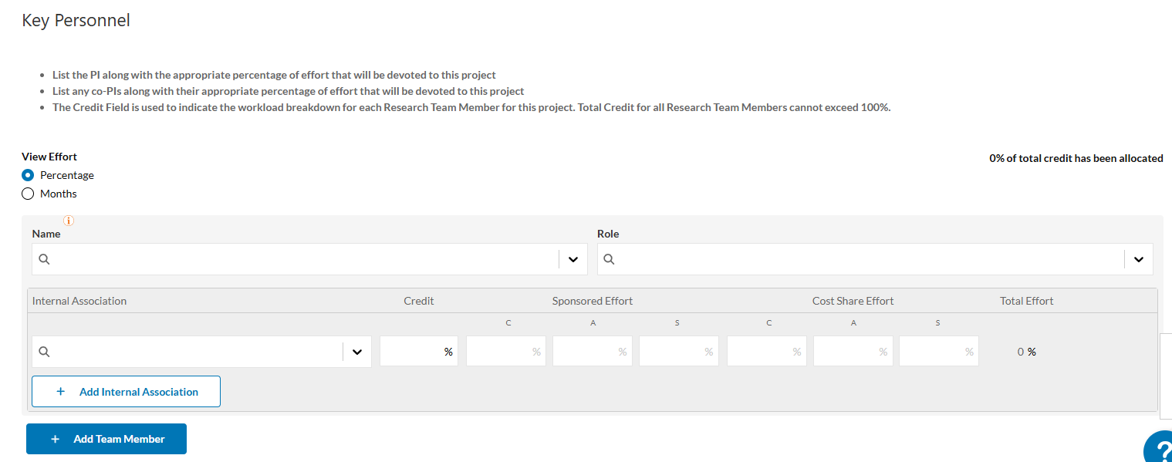

If there are co-PIs, you can add them by clicking the “Add Team Member” tab. Only enter PI and co-PIs. Individuals with other roles (e.g., GRAs) do not need to be included.

For the effort table for the PI and each co-PI, if any, you may leave the Internal Association, Sponsored Effort, Cost Share Effort blank. In the Credit field enter the percentage the PI and each co-PIs are committing to the project, for the purposes of indirect cost distributions to relevant units. **The total among the PI and co-PIs must equal 100%.**

Complete the remaining questions on the page. Responses to these questions are used to ensure those that need to review and approve your proposal are included in the approvals queue.

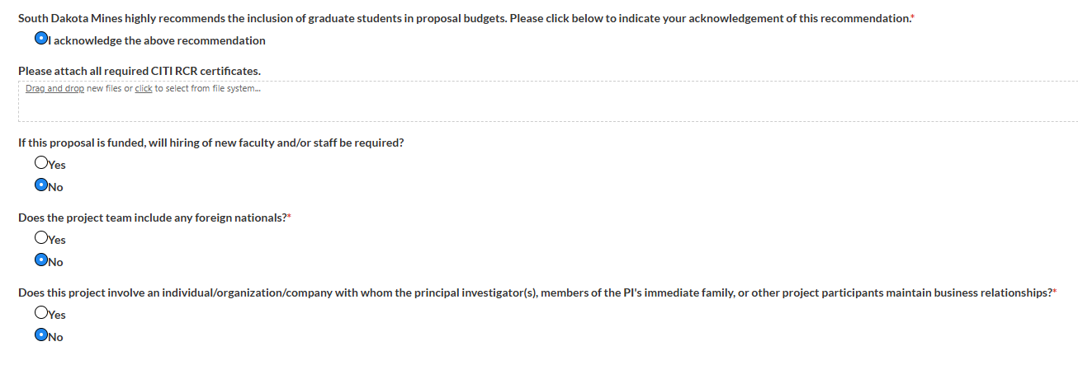

Summary Budget Tab
The following fields will be completed by Jan Matson.
Total Direct Costs F&A (indirect cost) Base
Total Indirect Costs Specify ‘Other’ F&A base
Total Costs Upload a detailed proposal budget
F&A (indirect cost) Rate Upload a budget justification

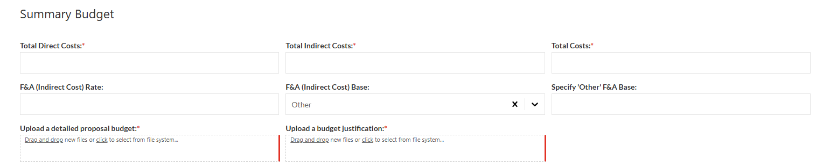

The other questions on this page may be completed by the PI. Responses to these questions are used to ensure those that need to review and approve your proposal are included in the approvals queue.

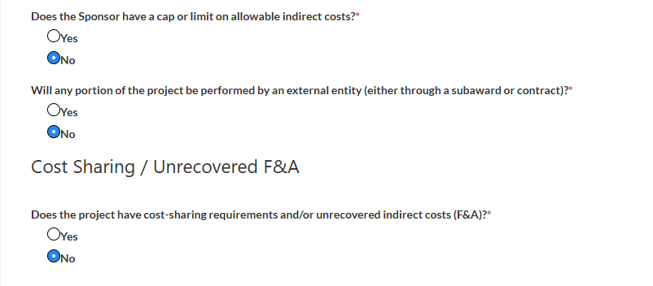
Regulatory Compliance Tab

Complete this page. Responses to these questions are used to ensure those that need to review and approve your proposal are included in the approvals queue.

Performance Sites Tab

Complete this page. Responses to these questions are used to ensure those that need to review and approve your proposal are included in the approvals queue.

Subawards/Contracts Tab (This tab will only appear if you respond yes to the “Will any portion of the project be performed by an external entity (either through a subaward or contract)” on the Summary Budgets Tab.

Complete this page for each subaward/contractor.
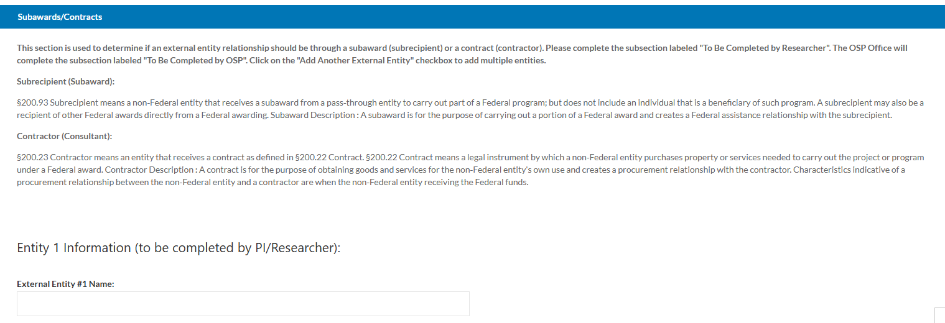

13: Foreign Support & Collaboration

Complete this page. Responses to these questions are used to ensure those that need to review and approve your proposal are included in the approvals queue.

14: Intellectual Property

Complete this page. Responses to these questions are used to ensure those that need to review and approve your proposal are included in the approvals queue.

15: Additional Information

Add any notes/attachments as needed for OSP.

